**Experiment No. 6**

**Aim:** Perform and evaluate Clustering Algorithms using any open-source tools

**Theory :**

Step 1: Launch Weka: Open Weka and click on the &quot;Explorer&quot; tab, which is used for data preprocessing, modeling, and evaluation.

Step 2: Load your dataset: Click on the &quot;Open file...&quot; button in the &quot;Preprocess&quot; panel to load your dataset into Weka. Make sure your dataset is in a compatible format, such as ARFF.

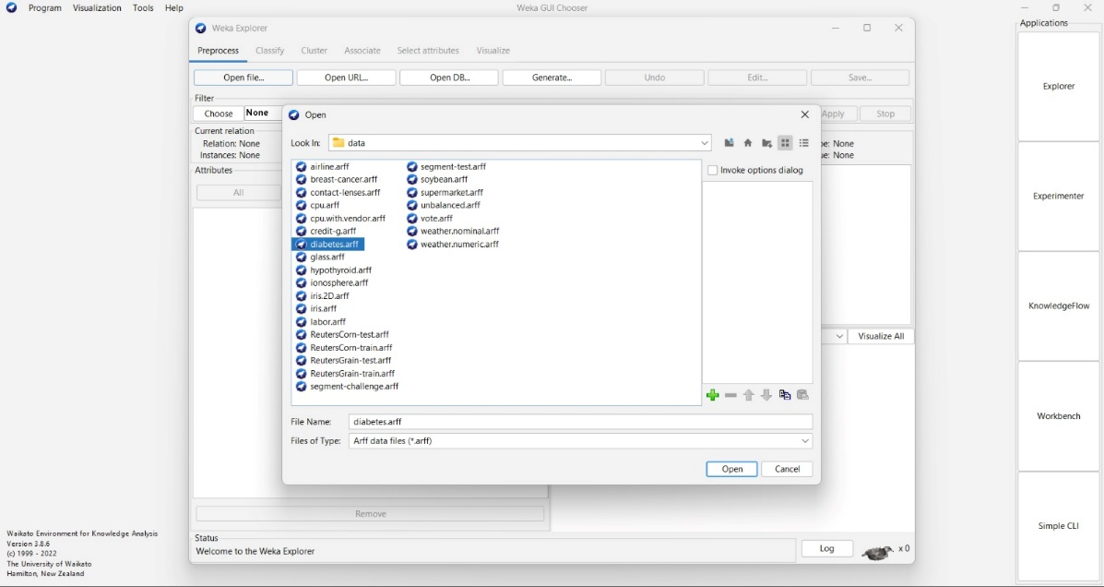

Step 3: Select the SimpleKMeans algorithm: In the &quot; Cluster&quot; panel, click on the &quot;Choose&quot; button next to the Clusterer dropdown menu. Then, navigate to weka.clusterers; and choose SimpleKMeans from the list.

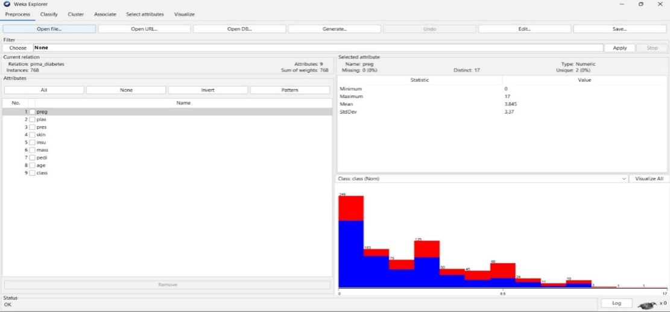

Step 4: Configure SimpleKMeans settings: Click on the &quot;SimpleKMeans&quot; option in the &quot; Choose a clusterer&quot; window to access the settings. You can configure various parameters like the number of clusters (k) and distance metric.

Step 5: Set the number of clusters (k): Adjust the &quot; Number of clusters &quot; parameter to set the desired number of clusters in your dataset. This is an essential hyperparameter that determines the number of clusters the algorithm will generate.

* 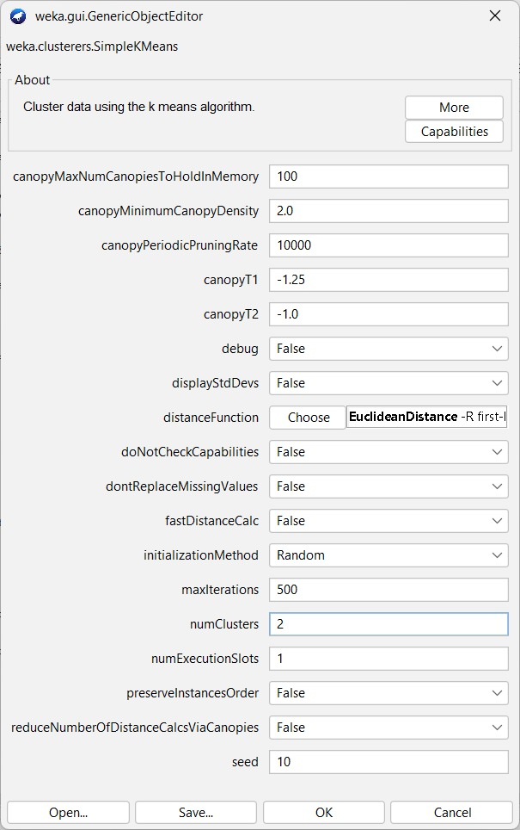

**Step 6:**Set the number of clusters (k): Adjust the &quot;Number of clusters &quot; parameter to set the desired number of clusters in your dataset. This is an essential hyperparameter that determines the number of clusters the algorithm will generate.

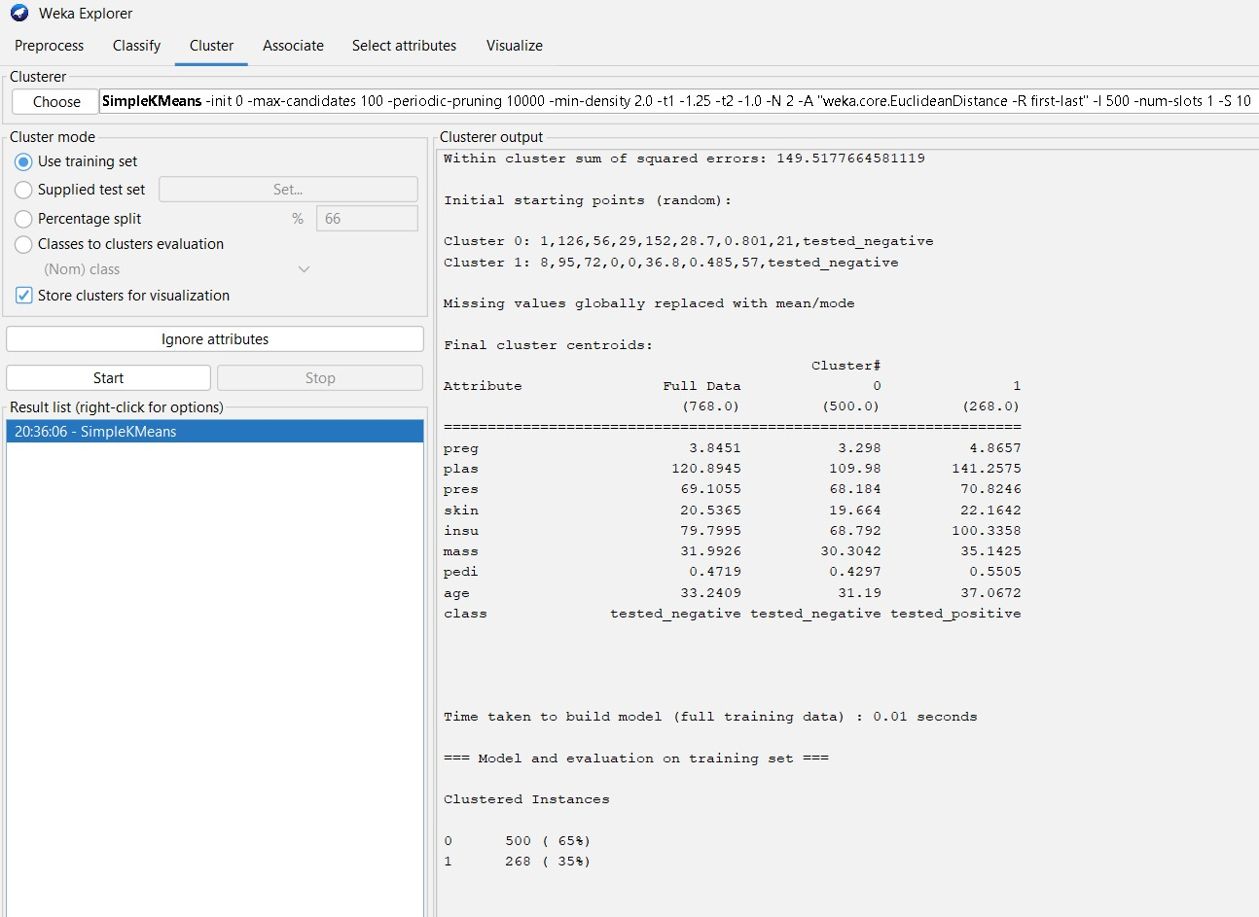

**Step 7:** Set the number of clusters (k): Adjust the &quot; Number of clusters &quot; parameter to set the desired number of clusters in your dataset. This is an essential hyperparameter that determines the number of clusters the algorithm will generate.

**Step 8**: Visualize the clusters: In the &quot; Cluster &quot; panel, click on the &quot; Visualize cluster assignments &quot; button to see a visualization of the clustered data. This will plot the instances with different colors representing different clusters.

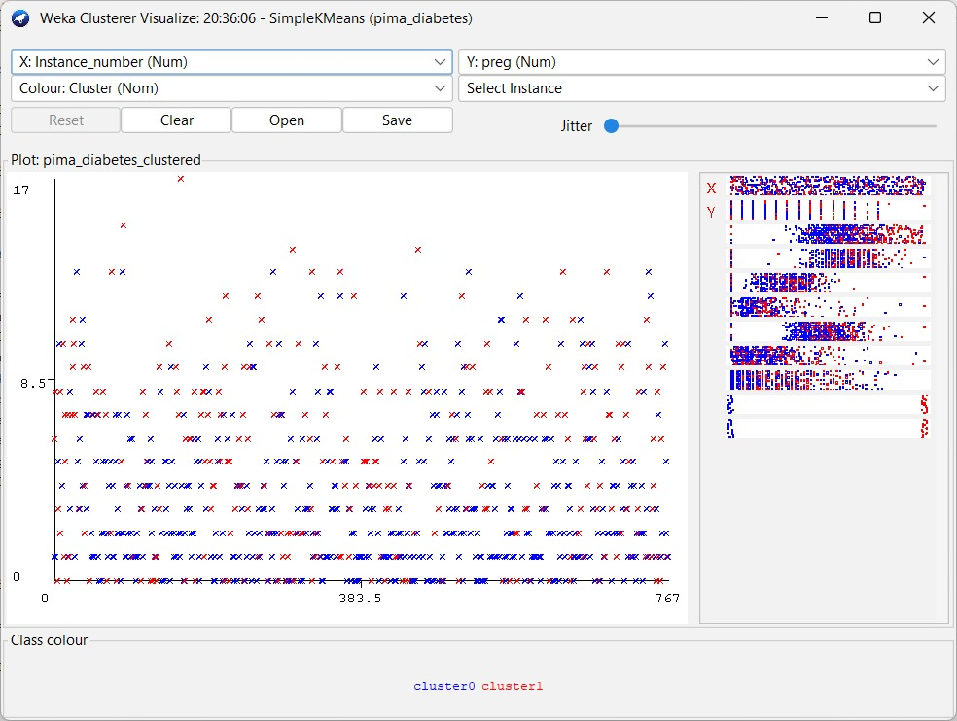

**Conclusion :**Hence we performed Clustering Algorithms using open-source tool WEKA.